SANIMAL – Scientific Animal Image Analysis

David Slovikosky

**Background:**

In May 2016 I was made aware that the School of Natural Resources and the Environment (*SNRE*) department at the University of Arizona was using software that no longer met department requirements for analysis of image data taken by camera trapping. The department sets up motion detector-equipped cameras in wildlife habitats to take pictures for many months. The memory cards are then retrieved, the images are collected and sorted by various researchers such as high school students, university professors, and retired people who do it as a hobby. Images are sorted or *tagged* by hand with GPS location, species, and number of animals. These researchers then aggregate their data into collections which are manually stored on hard drives or servers. Finally, analysis software is run on the tagged data to produce meaningful output used for research.

Originally this task was accomplished with a suite of FORTRAN programs written by Dr. Jim Sanderson. The heart of this software suite is made up of two programs, *DataOrganize* and *DataAnalyze*. *DataOrganize* is used to sort image metadata into a special format, which is then followed by *DataAnalyze* which takes sorted data as input and creates a large text file as output. This *output.txt* file contains thousands of lines of summary statistics on the data in the form of ASCII charts which is heavily used by the SNRE department. A sample screenshot of this output is shown below:

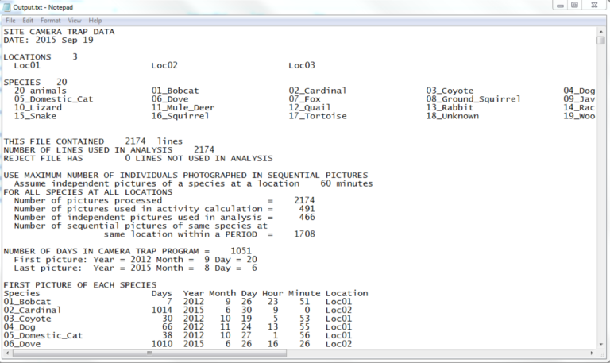

This software package has been used for many years and is currently kept up-to-date by Dr. Sanderson. Updates are released as researchers find bugs in the existing calculations or define a new analysis they would like to see. Unfortunately, this software is limited in its application. More specifically, *DataOrganize* and *DataAnalyze* are lacking in the following areas:

1. The source code is in FORTRAN and not easily available for custom modification
2. The sorting process for data is very tedious
3. Command line execution of the program can easily crash if the inputs are incorrectly formatted, usually without any error description of what went wrong
4. Output is in text format only and can be challenging to parse
5. Analysis can only be performed on local data making it difficult to collaborate

***DataAnalyze* and *DataOrganize* Deficiencies:**

*(1) DataAnalyze* and *DataOrganize* are written in FORTRAN and the source code is currently privately controlled. While FORTRAN was a cutting-edge language at its time, it has aged and does not provide many features standard in modern languages. Most importantly, it is challenging to create a user interface in FORTRAN which is essential in modern applications. Because the software is closed source, any modification to either program is impossible. This means there is no way to see how any of the analysis are done other than the documentation given by Dr. Sanderson. While this documentation does give some insight on how the numbers are computed, it can be difficult to reverse engineer many of the numbers.

(2) As previously stated, images taken on camera traps must be *tagged* with location and species. Locations are comprised of a name and UTM coordinates. Species are given by a name, and finally count specifies the number of the species in the image. The image date and time taken must also be extracted from the image metadata. *DataOrganize* performs this *tagging* process by parsing a directory structure as well requiring an external tool to extract image date and time taken. The *tagging* process begins by renaming all images in the following format: “Year Month Day Hour Minute Second.jpg” by a third-party program named “Renamer”. This software simply reads the image file metadata and renames the file accordingly. All credit for this program is found below:

https://www.den4b.com/products/renamer

Renamed images are then copied into a directory structure pictured below (taken from Dr. Sanderson’s HowTo slides):

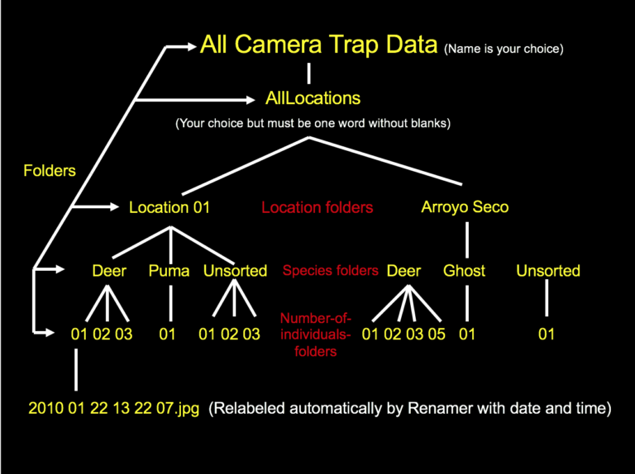

This directory structure is then parsed by *DataOrganize*. Location UTM coordinates are read in from a separate file which is provided as a standard-in argument. These coordinates must be in a very specific format to be parsed correctly, otherwise the FORTRAN software will crash. After a few seconds of execution, *DataAnalyze* creates a few output text files, of which *output.txt* contains most of the analysis. This entire process of renaming the images and then copying them into a multi-layer directory structure is incredibly tedious and lacks scalability. Images that contain multiple species are duplicated in the directory structure leading to data redundancy.

(3) *DataAnalyze* and *DataOrganize* are Windows executables which are run from the command line. This immediately poses a problem to anyone using a Mac or Unix based system, because they simply cannot use the software. Users must open a terminal and answer questions asked by the software such as, “Enter folder name containing all camera trap locations, then ENTER”. There are many challenges when using command line applications especially to users who lack technical knowledge, and many of the users using Dr. Sanderson’s softwarehave never used a command line-based program. These challenges include understanding relative vs absolute file paths, realizing the importance of capitalization, and being able to interpret error messages. *DataAnalyze* and *DataOrganize* do not provide any detection for user error and can often crash as a result with a simple “Fortran Stop”. All these specifics mean the average user cannot easily learn how to use these programs and needs to be taught by someone who has used the software.

(4) The output created by *DataAnalyze* is simple ASCII. This output is incredibly difficult to parse, both by humans and computers. Many researchers want to do further analysis on the output created by *DataAnalyze*, but due to the irregular nature of the text writing a script to read all the values can be very time consuming. Output lines are printed with many arbitrary restrictions, such as location and species names are capped around 26 characters and padded with spaces if too short. This string length value varies from chart to chart. Some charts are very wide due to having many columns and *DataAnalyze* splits these charts in two parts with half the data in the first, and half in the second. After talking with some researchers who use this software, one said “We just copy the ASCII charts straight into Microsoft excel and let excel’s built in parser parse the chart’s values into cells. We then graph the data using excel.” In one small study, 2,500 images were analyzed which resulted in an *output.txt* file 3000 lines long. Many of the charts featured in the output contained the same data but aggregated in many different possible permutations. As an example, some charts group images taken by month, and others group images by season. This results in two separate ASCII charts which are scattered somewhere in the 3000 lines of output. In larger studies, millions of images are often involved which leads to ASCII *output.txt* files that are significantly large. The output of *DataAnalyze* is static and non-interactive. This makes the analysis software very difficult to use for anyone untrained. The SNRE department has a special class each year that is designed to teach citizen scientists how to understand and parse the *output.txt* file which should not be the case with analysis software.

(5) Researchers rarely work alone. There are several different projects currently on-going in the SNRE department, each with a unique set of researchers, cameras, and species to track. These projects have a requirement to store all their images in a single location where analysis can be done over data from all researchers. Because Dr. Sanderson’s software only runs on local data, one massive, terabyte sized directory structure is stored on a server. Citizen scientists first sort their portion of the data and upload it to the server. The folders are merged, and the image collection is updated. Later a researcher can execute the software on the directory. This system methodology has several drawbacks. Firstly, researchers who may live around the world need to “upload” their images to the server by sending USB drives in the mail to someone who works near to the server or upload their data to a Dropbox style service. Secondly, this setup completely disregards data security. Many projects need their images or location metadata to be kept private, this is to deter hunters or poachers who would abuse knowledge of species movements to track specific species.

**Scientific Animal Image Analysis (*SANIMAL*) Swing:**

To solve these deficiencies, it was clear that *DataOrganize* needed to be fully re-engineered and re-written from scratch. It was decided at first to simply replicate the *output.txt* created from *DataAnalyze* with limited new analysis. To begin engineering *SANIMAL*, a more modern language needed to be chosen. Three major languages were considered, C/C++, C#, and Java. C/C++ has the advantage of being efficient and supports a wide variety of libraries to create user interfaces. Unfortunately, C/C++ has compatibility problems when being deployed to a wide variety of operating systems such as Unix, Mac, and Windows. C# has the best user interface creation tools when being designed in Visual Studio. The language also supports modern language features such as data bindings and lambda functions. Unfortunately, C# is only compatible with Windows because it requires the .NET framework for execution so therefore also rejected. Finally, Java was considered for use in *SANIMAL*. Java supports a wide variety of operating systems including Unix, Mac, and Windows while also having a wide variety of user interface frameworks such as AWT, Swing, and JavaFX. One personal reason Java was considered is because I had taken a class, Computer Science 335: Object Oriented Development and Design the year before. This course teaches proper objected-oriented design principles as well as user interface design using Java’s Swing framework. For these reasons, Java was chosen instead of C/C++.

The first version of *SANIMAL* addressed many, but not all problems inherent in the previously used software. More specifically, it had the following advantages:

1. *SANIMAL* was written in Java using version control
2. *SANIMAL* used a user interface making the data sorting process much easier
3. Basic new output was introduced to increase analysis productivity

***SANIMAL* Swing in Detail:**

(1) As previously mentioned, Java supplies 3 different user interface frameworks, AWT, Swing, and JavaFX. JavaFX became Oracle’s newest UI standard with the release of Java 8, but was only released after the initial start of the software development effort. Due to my experience with Swing, Swing was chosen for the first version of *SANIMAL*. Because Java is supported on most operating systems, Swing would allow *SANIMAL* to use one unified interface for almost all operating systems.

*SANIMAL* was engineered with object-oriented design principles in mind. Most notably, the Observer-Observable, Model-View-Controller, and Singleton design patterns were implemented. This made the code very robust to new changes and new features were easily implemented. All code was documented using JavaDoc further increasing readability.

It was also decided to use GitHub to perform version control on the code which was not present in the original software. GitHub allows developers to collaborate on the development of a project as well as providing a detailed list of changes in every code commit. Using GitHub also allows the project to be open source, which enables any user to download and modify the code to their liking.

(2) Instead of using a directory structure, a user interface was created to tag data. A screenshot of the first generation interface design is pictured below:

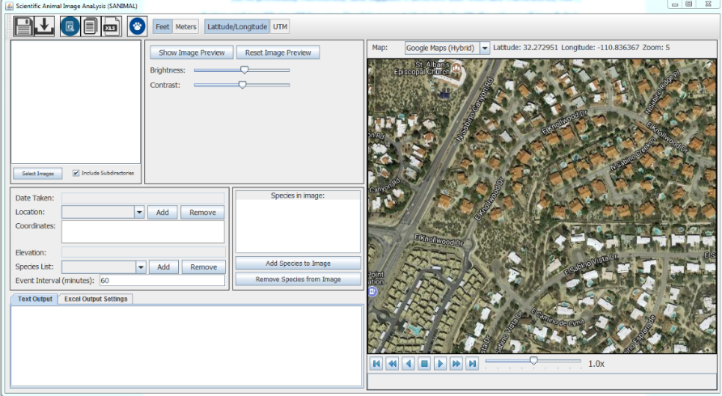

The user interface allows users to tag data using the following steps:

1. New locations are added to the program for each location data was collected at. A location consists of a name, a position, and an elevation.
2. A species is added for each species photographed in the data. A species only consists of a common name.
3. Images are imported using the select image button.
4. The user goes through each image and selects the location and species present in the image. The date and time taken are automatically read from the image EXIF metadata. This removes the requirement to use ReNamer to give images a specific name based on date and time.

One major problem encountered when tagging camera trap images is that night time photos may be very dark on the edges, making it difficult to see what species triggered the motion detection. If a user wanted to tag a dark image using *DataOrganize*, an external program such as photoshop must be used to temporarily adjust brightness, contrast, and zoom of the image. To address this, *SANIMAL* can open a preview window of the image which supports temporary zoom, brightness, and contrast adjustments. This makes the tagging process much more efficient because users no longer need external tools to view dark images.

Another problem encountered is that users need a way to save their tagging progress to continue later without needing to keep the program open. If a user wants to save the current program state for later, *SANIMAL* has a save button which serializes its internal data model and saves it into a file. This file can then be opened through the program and all data such as species, locations, and images are loaded in.

It quickly became clear that researchers from all different kinds of regions were going to use this software, and therefore it was important to support different units of measurement. Elevation can be displayed in feet or meters and location can be displayed in latitude/longitude or UTM. When importing photos, *SANIMAL* asks the user whether they are entering location position in UTM or latitude/longitude, and if elevation is given in feet or meters. This small change made the software more flexible than *DataAnalyze*, which only supported UTM and meters.

(3) The largest flaw inherent in *DataAnalyze* is its inability to clearly show analysis results. To start, *SANIMAL* could recreate the *DataAnalyze* output. Recreating the output allowed *SANIMAL* to appeal to researchers used to the old system, and then build upon it. Because source code to *DataAnalyze* was not available, the *output.txt* was reverse engineered using Dr. Sanderson’sdocumentation as well as trial and error. In the reverse engineering process, many major bugs were discovered in *DataAnalyze* unknown to researchers at the time. *SANIMAL*’s algorithms fixed all encountered bugs.

To improve analysis, a map is included which displays a marker at each registered location. The map allows selection from a list of various map providers like google maps, open street map, and virtual earth. Each provider provides a different set of map tiles which can be used to view street, satellite, or terrain data. This map allows playback of image data based on date and time taken. A progress bar lets users to watch the data like a video from the first image’s date to the last one. When the playback gets close an image’s date taken, an image thumbnail is displayed at the location the image was taken. This allows researchers to visualize where images were taken and what time periods throughout the study.

***SANIMAL* Swing Deficiencies:**

After some basic testing was done on the first version of *SANIMAL*, it was clear that many issues were not fully addressed, and additional features were requested. Most importantly, *SANIMAL* did not use a database backend which made it difficult to collaborate. Species and location lists needed to be created or manually loaded every time the software was opened. Images were not directly tagged with EXIF metadata, so any species and location data were purely stored inside *SANIMAL* or a saved project file. This meant it was impossible to share images with other researchers without passing project files. While the image tagging process was much faster than on the original *DataAnalyze* tool, the process was still tedious. Many mouse clicks were required to create a species and tag it onto an image. The analysis provided by *SANIMAL* was basic and, other than the map display, the same as *DataAnalyze*. It was clear that the first iteration of *SANIMAL* was insufficient, and a second iteration of the software was needed.

***SANIMAL FX***:

To improve upon *SANIMAL*, it was clear thatthe UI and user workflow needed to be redesigned to support more modern features such as drag and drop and cloud-based storage. By this time, Java 8 was fast becoming the standard in most Java applications. Java 8 came prepackaged with the new JavaFX graphics library which Oracle meant as a replacement to Swing. JavaFX has many similarities to the C# UI such as the ability to perform data bindings and support the Model-View-ViewModel (MVVM) design pattern. The default controls also had a much more modern look than previous frameworks which made it more appealing to users. Because of this, JavaFX was chosen as the UI framework for *SANIMAL*, and the software would be known as *SANIMAL FX*.

All issues discovered in *SANIMAL*, and *DataAnalyze* were addressed within the new revision of software. More specifically, *SANIMAL FX* had the following advantages over original *SANIMAL*:

1. *SANIMAL FX* was written in JavaFX which allowed for cleaner UI design
2. Metadata was directly embedded into images
3. Analysis was performed using SQL-like queries and results were returned in the form of simple comma separated values (CSV)
4. Security concerns were addressed with the introduction of authentication
5. CyVerse was chosen as the database backend to store images as opposed to a local PC

***SANIMAL FX* in Detail:**

(1) With the introduction of JavaFX as the new Java UI standard, *SANIMAL* needed its UI to be updated to this standard. User interfaces are created using an XML like structure called *FXML*. *FXML* files are often referred to as the *View* component of a JavaFX application. *FXML* files have the advantage of being Cascading Style Sheet (CSS) compatible, meaning all UI elements may be targeted with a CSS selector and then visually styled. Each *FXML* file is associated with a single controller file, which is known as the *ViewModel*. This controller file receives events which originate from the *View* and can then update the *View* and/or the *Model* accordingly. The *Model* is comprised of Plain Old Java Objects (POJOs) which contain observable fields, known as properties. Observable fields simply notify any listeners whenever their state changes. Each Java primitive has its own property equivalent, while custom object types must be manually made into properties. The *ViewModel* can then bind properties in the *Model* to properties in the *View* which creates a link. Whenever the *View* changes, the *Model* is automatically updated to reflect that change. If the *Model* is updated internally, the *View* will automatically reflect that change as well. The benefit of using the *Model-View-ViewModel* design pattern is that files are highly decoupled. More specifically:

- The *Model* knows nothing about the *View* or the *ViewModel*, it just supports a set of actions and notifies any listeners of those actions.

- The *View* knows nothing of the *Model*, it just defines the structure of the UI while forwarding any important events to the *ViewModel*.

- The *ViewModel* finally “glues” the *Model* and *View* together using bindings. It also updates the *Model* when any action events are received from the *View*.

(2) The original *SANIMAL* program stored all metadata information internally, which meant metadata was useless to any external application. *SANIMAL FX* writes metadata straight into the EXIF tags of the image file which ensures that any program can read the metadata. It also allows *SANIMAL FX* to automatically read metadata from previously tagged images.

(3) It was clear that the *output.txt* file created by *DataAnalyze* was lacking, and the analysis provided by the map in *SANIMAL* was not enough. JavaFX comes packaged with a 3D rendering API as well as a chart creation API. After asking many researchers and scientists about the charts/graphs they would like to see, it became clear that the list was endless. Each researcher wanted a slightly different permutation of the data and maintaining 25+ charts was unreasonable. Instead, it became much more important to provide the raw data in an easy-to-parse format, such as CSV. Researchers could then use their own programs and software libraries to create charts such as Excel, R, Java, Python, or JavaScript.

(4) When using the original *DataAnalyze* and *DataOrganize* programs, all image data was stored on PCs or Linux servers at best. These servers were often run by different organizations with various administrators which meant the data was lacking security. Each organization needed to secure their own data with their own permission system. An example of an important data breach occurred in 2017, one researcher in the SNRE department stole many images with confidential location data on them and posted them publicly on the web. This incident showed the need for additional security to be present on the image data. To solve this issue, *SANIMAL FX* requires the user to make an account with CyVerse before logging in to use the software. CyVerse also provides many other features which are described below.

(5) CyVerse is a company with the goal, “To design, deploy, and expand a national Cyberinfrastructure for Life Sciences research, and to train scientists in its use” (cyverse.org). The company provides its users with a data store for terabytes of data, a high-performance execution framework for machine learning, and a way to authenticate users. *SANIMAL FX* makes use of all three of these features using a library called *Jargon*. *Jargon* is a Java-based implementation of the iRODS protocol which CyVerse uses as its interaction API. *SANIMAL FX* makes use of the authentication API to verify users are allowed to use the software. Once logged in, users tag their images with EXIF metadata and then upload the images to the CyVerse datastore. These images have permissions applied to them which ensures that no unwanted users can see the images or the image metadata. Images are indexed by metadata tags which allows them to be queried by the high-performance execution framework. These queries are then converted into CSV, where researchers can perform their analysis.

***SANIMAL FX* design challenges (UI):**

The first UI the user is presented with is the log in screen. A screenshot is shown below:

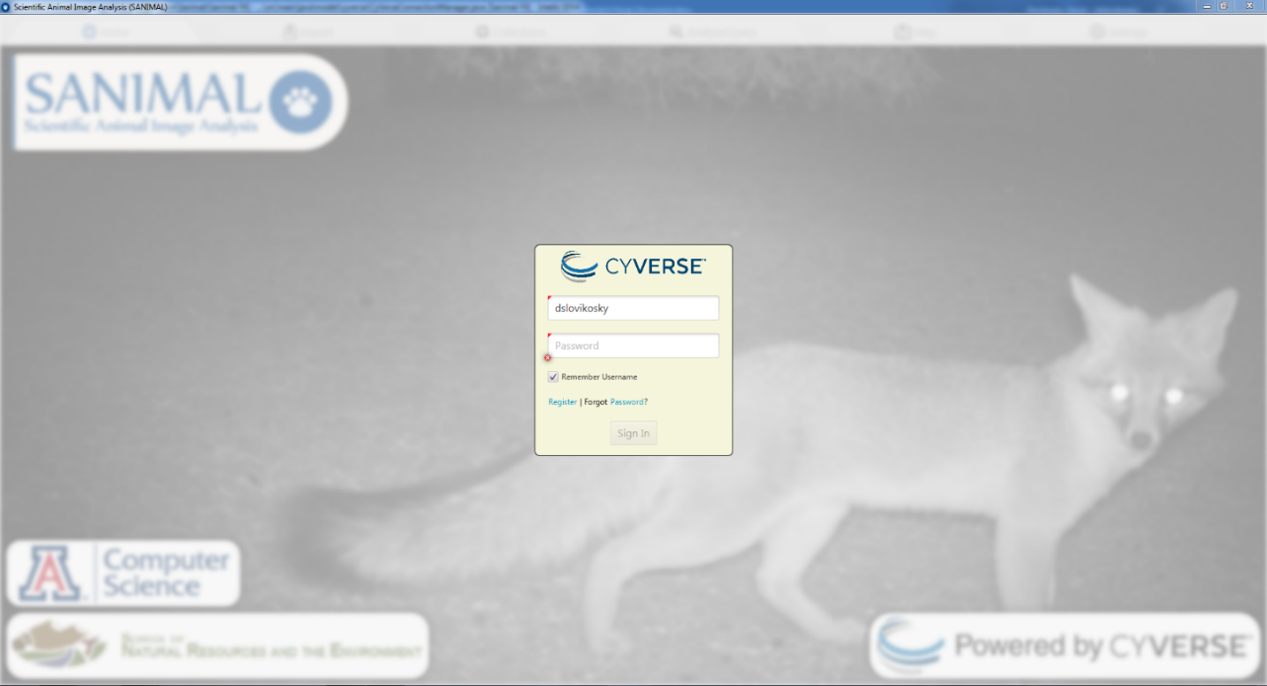

The login UI features a login username and password as for most software. There is a checkbox which allows the user to remember the username for the next *SANIMAL FX* login. There is no “Remember Password” checkbox because remembering passwords is difficult to do without storing the password in plain text. Encryption needs to be used and represents a significant challenge to implement. The UI also features register and forgot password links to CyVerse’s website. After logging in, the user is brought to the home screen which features 6 tabs on top. Each tab serves a specific task in the workflow of the software:

* **Home tab** - This is the software start page when the user logs in, it does not have functionality other than crediting developers
* **Import tab** – First functional tab used for loading photos into the program. Provides a tagging interface with metadata such as species and location
* **Collections tab** – This is the next logical step after tagging photos. The interface allows uploading images to a project (also known as a collection) as well as downloading existing uploaded images for editing. Also used to edit collection permissions
* **Analyze/Query tab** – Final step after uploading data, allows users to query images uploaded given a set of constraints or filters
* **Map tab** – Utility tab which shows all locations on top of Google Maps
* **Settings tab** – Utility tab which allows the user to change various settings like date and time format

**Home Tab:**

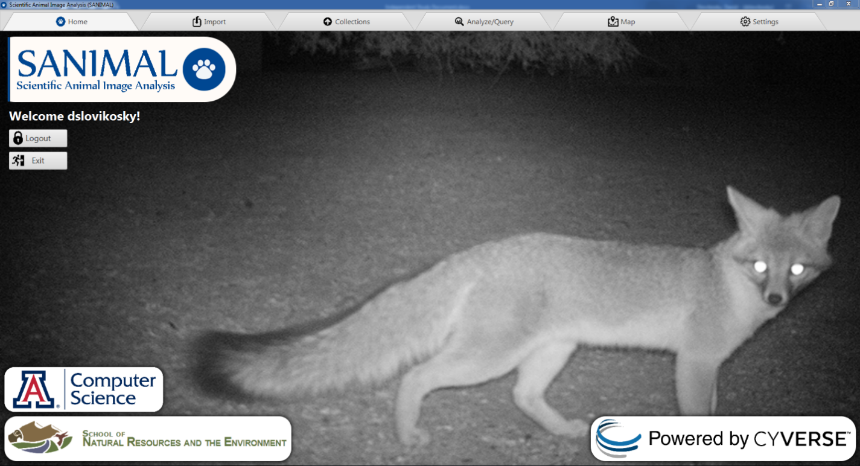

The bottom of the UI features links to the University of Arizona Computer Science and School of Natural Resources and the Environment links who developed *SANIMAL FX*. It also has a link to CyVerse’s website. The home UI also has an exit button to exit the application, and a logout button. Users requested a logout button when testing so it was added, the logout and exit button have the same function.

**Import Tab:**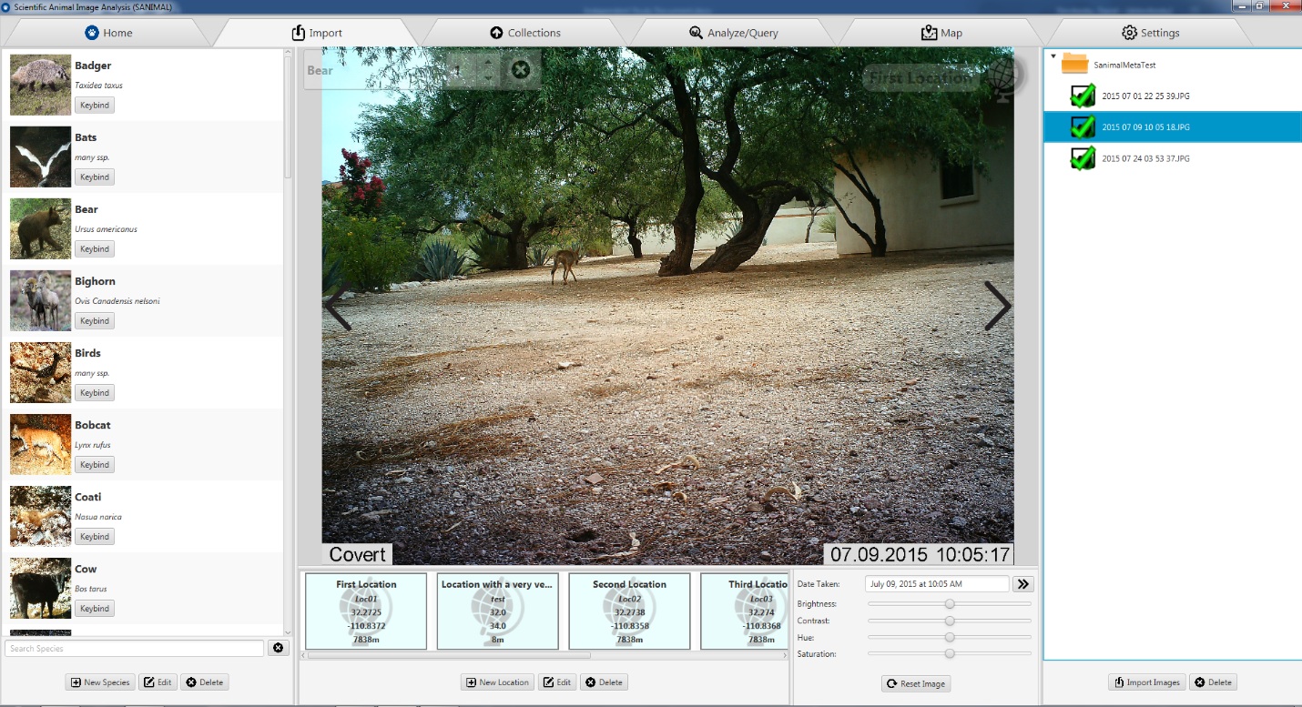

The import tab is used to import images into the program and customize each image’s metadata. It features a species panel on the left side where users can see their own customizable list of species. A species entry in the list is made up of the following data:

* Common name
* Scientific name
* Icon web URL
* Key bind button (Used to “hotkey” a species for quick tagging)

The right side features the image panel, where all imported images are stored. If the images imported are not local but on the CyVerse datastore, they will have a blue cloud as the background instead of the standard white. Image icons change reflecting their status as listed below:

* Untagged – Image icon is the default
* Location tagged – Image icon shows a location marker on the right side
* Species tagged – Image icon shows a paw marker on the left side
* Species and Location tagged – Image icon shows a paw marker and location marker with a check mark over top

Clicking an image shows a preview of that image in the center preview panel. The center preview panel shows the current list of species in the image on the top left, and the location the image was taken at on the top right. Mouse scrolling allows for zooming in and out of the image. The bottom panel shows a list of locations on the left, and temporary image adjustments on the right. Temporary image adjustments were requested to help tag dark photos where species may be difficult to distinguish. Previously researchers often needed to open images in a third-party tool such as Photoshop, but now these adjustments were built directly into *SANIMAL FX*. These temporary adjustments include:

* Brightness
* Contrast
* Hue
* Saturation

The date and time the image was taken is also shown above the adjustments. The “date shift” button to the right of the date taken allows users to modify the date and time the image was taken. This is useful when cameras are incorrectly configured and store incorrect dates on images. Users tag photos by drag/dropping species and locations onto the center preview panel or specific images on the right panel. Locations may also be dropped onto a directory in the right panel to tag all images in that directory with the same location. EXIF metadata is automatically written to disk whenever a change is detected on an image.

**Collections Tab:**

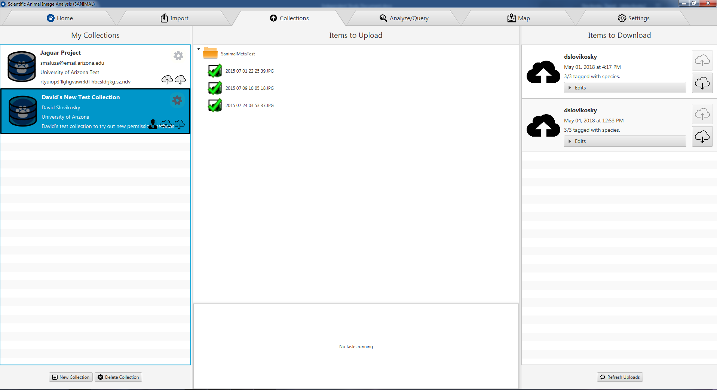

The collections tab shows a list of collections the current user is a part of on the left panel. Each collection entry in the list has the following fields:

* Name
* Contact Information
* Organization
* Description

The currently logged in user’s permissions are shown below the gear on the right side of each collection entry. The profile icon means the current user owns a given collection. The cloud with an up arrow means the user can upload images to a collection, and the cloud with a down arrow means the user can query or read images from a given collection. The center tab shows a list of imported images and their statuses. Directories can be dragged from this center list onto a collection to begin the upload process. The progress of currently uploading images is displayed on the bottom. The right side of the collections tab contains a list of uploads from other users. Here users can download other users’ uploads and modify them in case there were errors.

**Analysis/Query Tab:**

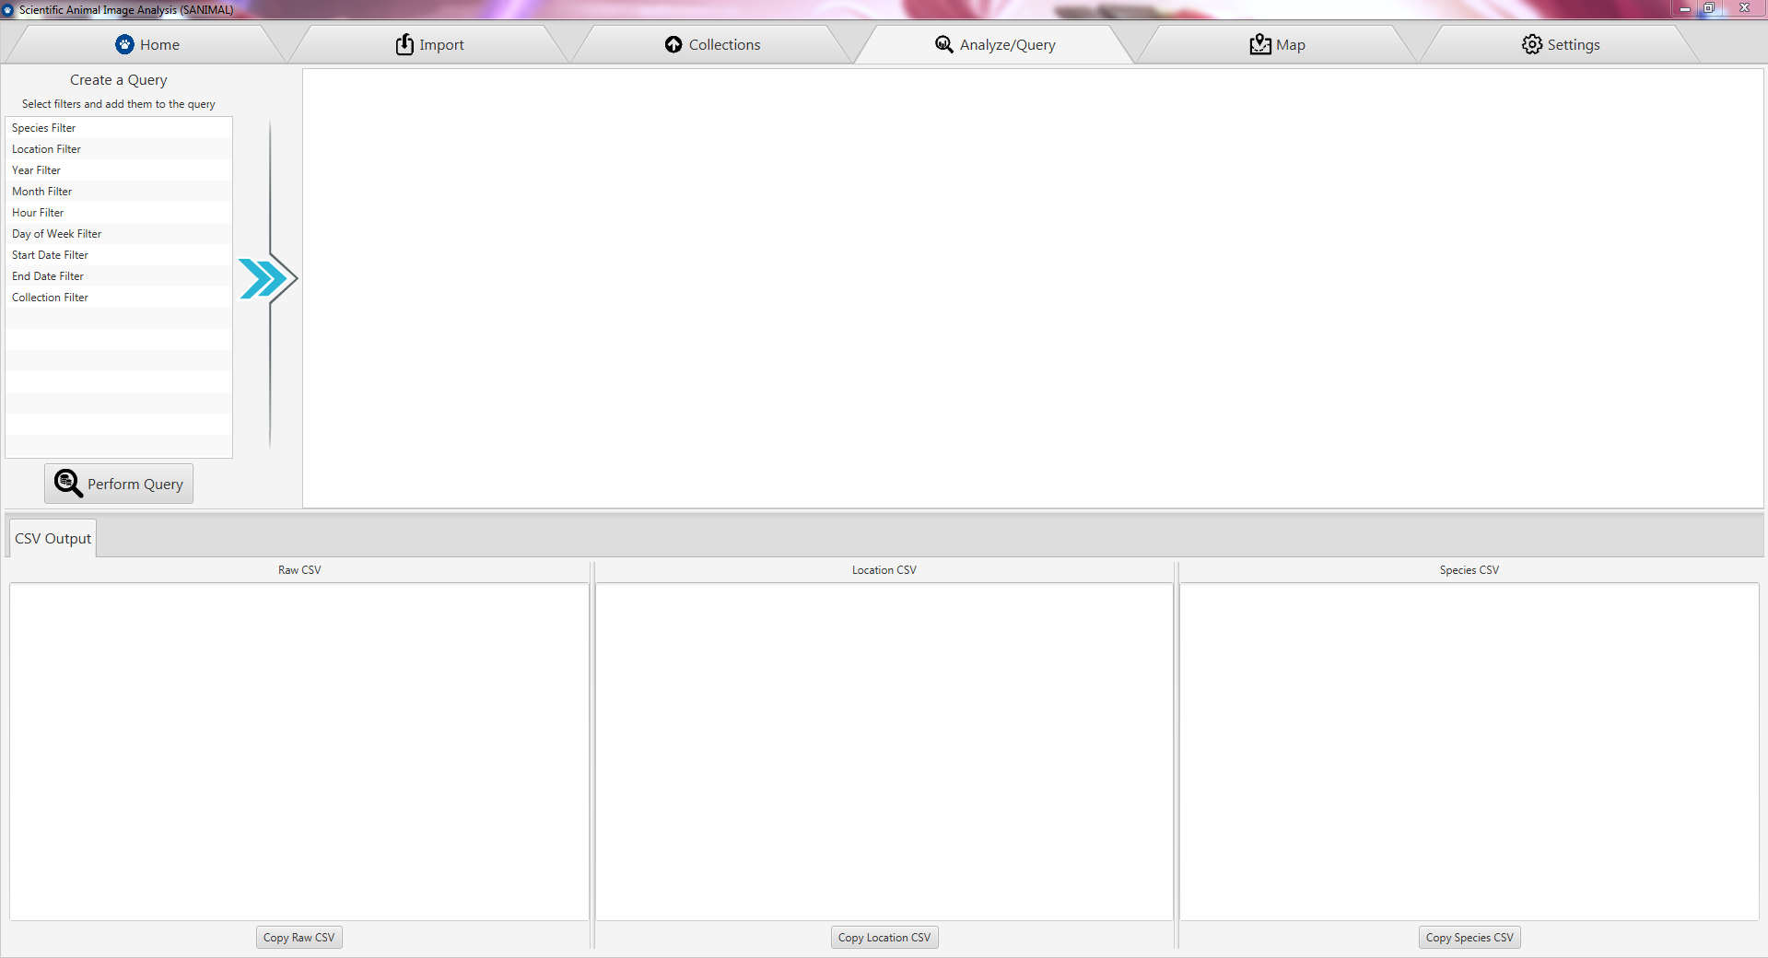

The analysis/query tab is responsible for creating SQL queries against uploaded data on CyVerse. The top left features a list of filters that can added into a query, and the right side shows a list of specific filter settings. After the user adds a list of filters and customizes each one, they press “perform query” which queries CyVerse. The result is returned as a CSV on the bottom.

**Map Tab:**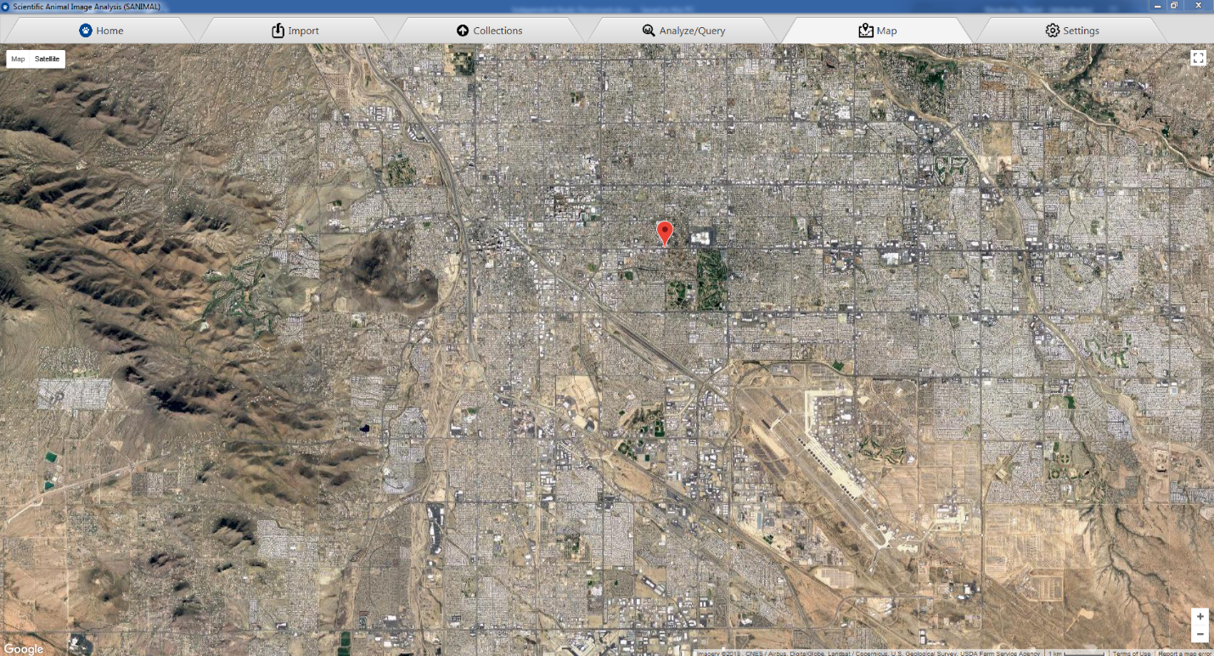

The map tab allows users to visually see their locations on a map. The map data is provided by Google Maps. This allows for double checking of location lat/long coordinates to ensure they are in the correct locations.

**Settings Tab:**

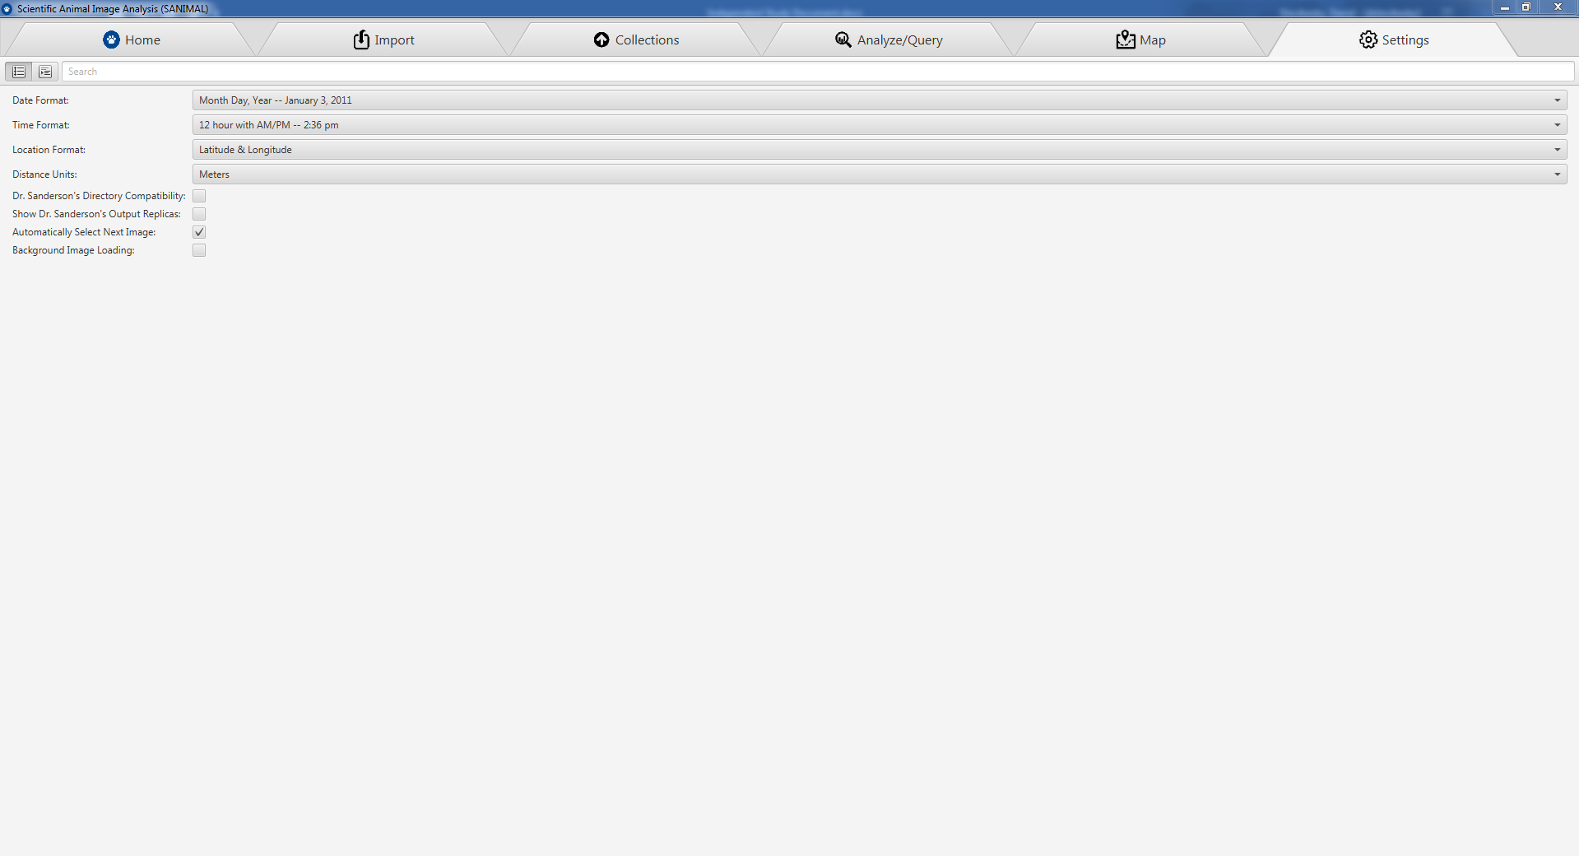

The settings tab contains 8 settings the user can adjust to help make the program easier to use. These 8 settings are:

1. Date format (ISO/Month Day Year/etc)
2. Time format (24hr/AM-PM)
3. Location format (UTM/Lat long)
4. Distance units (Feet/Meters)
5. Dr. Sanderson’s Directory Compatibility – Allows importing legacy data in the directory structure format specified by *DataOrganize*
6. Show Dr. Sanderson’s Output Replica – Shows the *output.txt* equivalent of the data returned from the SQL query on the Analysis/Query tab
7. Automatically Select Next Image – Allows the user to automatically jump to the next image whenever tagging species on an image. This speeds up the tagging process considerably
8. Background Image Loading – Places the loading of images onto a separate thread to reduce performance impact of loading images off a slow SD card or hard drive.

***SANIMAL FX* future work:**

*SANIMAL FX* accomplished all the goals initially set by the project. However, as the project progressed, it became clear that *SANIMAL FX* had significantly more potential than originally outlined. As researchers from various departments began testing the software, many non-trivial features were suggested that would make *SANIMAL FX* a significantly better product. While I personally do not have the time to implement these changes, I believe the next phase of *SANIMAL FX* is to implement the follow changes:

1. Allow the user to tag additional, custom metadata about species and locations
2. Have machine learning automatically tag images
3. Allow importing of other image file formats such as PNG or TIFF as well as video formats
4. Make the map more interactive
5. Update the workflow to make species list a “per-collection” entity instead of a “per-user” entity

(1) Currently, *SANIMAL FX* uses a static metadata model for locations, and mostly static metadata for species. A location is defined by an elevation, latitude, longitude, name, and site code. These do not change from image to image but are purely static. A species is defined by a name and scientific name which also do not change from image to image. The actual amount of a given species in a specific image is dynamic, because it may change from one picture to the next. As many researchers pointed out, certain projects may have additional dynamic species and location metadata requirements outside of species count. For species, these may include stripe count, gender, animal ID, and many more. For locations, additional metadata may come in the form of weather or environmental conditions such as raining versus not raining, river flowing versus dry, or grass height. These additional metadata fields would be optional key-value pairs used by specific projects.

(2) It is estimated that there are over 4 million images in one specific example project that have not been tagged with species or location. These images are sitting on hard drives just waiting to be processed by humans using *DataOrganize*, or now, SANIMAL *FX*. Unfortunately, this process takes hundreds of man hours, and that’s where machine learning comes in. Machine learning algorithms can take existing tagged images as input and then estimate what species are in untagged images. This would significantly improve the user experience, since users would upload a set of untagged images, and then be asked to verify some small subset of the images that the machine learning algorithm was uncertain of. CyVerse has already begun working on this process, but it’s still in early development and requires integration into the *SANIMAL FX* UI.

(3) The majority of camera traps are configured to take JPG images because that data is most helpful to researchers. In some cases, cameras are configured to take short 10 second videos or take images in other formats such as PNG. *SANIMAL FX* currently does not support other image formats because they store metadata in a different way. The software also does not support video, even though JavaFX supports videos in almost the same way as images. This would make implementation quite easy, but adding metadata to videos would be a more challenging task.

(4) While *SANIMAL FX* is significantly more usable than the original *SANIMAL* program, the map in *SANIMAL* is more feature rich. The *SANIMAL FX* map shows all registered locations on a google maps background. This can be useful for debugging location and camera positions but can be significantly improved. One suggestion was to add a video-like timeline on the bottom. A user would then perform an image query and get a list of results. The timeline would then visualize when the images were taken, with the first image on the far left, and the last image on the far right. The user would then use video-like controls to play through the data in day-by-day increments. When an image is hit on the timeline, the location marker would display the species taken and its metadata. This would be useful in tracking animal patterns, for example if a puma was photographed on one camera, then two hours later at a second camera close by, one can assume the puma walked from the first to the second camera. The map could respond by drawing an arrow with the estimated chance that the puma did in fact walk from camera 1 to camera 2 and that it wasn’t just a different puma. This map interactivity would be very useful to visually analyze the movements of species over the photographed area.

(5) One major flaw inherent in the *SANIMAL FX* user interface is that species and location lists are stored on a “per-user” basis, meaning each user has their own personal customizable list of species and locations. This can lead to user error, and in the case of machine learning can throw off the algorithm significantly. Different users may mistype the name of a species, and then images with the same species are tagged with different names such as: Rabbit, Rabitt, Rabt, Rabit, etc. The solution to this problem is to store location and species on a “per-project” or “per-collection” basis. This means project administrators would specify a list of species and locations for their image collection which could be modified if new species were discovered or locations photographed. Users of the collection would import images and specify which collection they would like to upload them to. The possible species and location lists would then be pulled from the collection and made unmodifiable. The advantage of this system is that the project administrator would have complete control over all species and locations reducing the chance of errors.